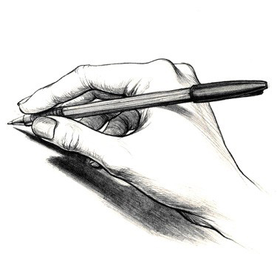

2012 B. K. Evans
The ground is wet;
Dark patches of water fill up the concrete that was once light.
All of this based around a bet,
This bet had an intensity of much height.

The sun doesn’t shine, but clouds cover the sky
Clouds of smoke, clouds of death, clouds that hide.
Buildings destroyed, the world kissing the universe goodbye,
Death instead of life, now it will abide.

No people move, no people can be seen,
No animals, no plants, no life.
Scientists, now on their theory, can lean,
But no one can hear their complaints; their heartache and strife.

It has now happened, just like they said it would.
Is it because of lack of faith and hope?
Has God come down and gotten us like we knew he could?
Or is this just another way that we humans could never cope?

When they said it would happen, some didn’t believe,
They are now up in heaven, living without a care.
But many stayed in the burning flames that deceive,
This is the punishment that they will forever bare.

Contrast

Your touch leaves me helpless.
Your trust dares me to believe in the love you offer;
An end to my darkness and my past forgotten.
You revive my hope and heart,
Promising your love and my happiness,
I tremble in your arms.
My walls crumble in your presence.
You make me fall apart with just one kiss,
One glance from your calm blue eyes can leave me breathless.
It’s torture to not have you here in my arms.
For so long there was no color in my world,
Until I found you.
I once denied myself the light,
Convinced I deserved the darkness.
Now my light shines forever in your eyes

Doubt
Elizabeth McAuley

Do I put my morality in the invisible hands of a being I do not understand?
I cannot see you.
I cannot feel you.
I cannot hear you.
The world sees you in different ways.
Wars are caused in your name.
In you I do not trust.
In you I cannot trust.
Man created you.
Incompetent people needing something to cling to.
Needing an explanation.
Needing an excuse.
To make themselves feel they have purpose.
They say I will burn.
But still I stand my ground.
I cannot give in to this idea.
That’s all it is.
An idea.
I will not.
I will stand before them.
Filled with doubt.

I Once Dreamed That…
Lauren Mathews
I once dreamed that I was purple
You were blue and I was purple .
I lived my life without a care
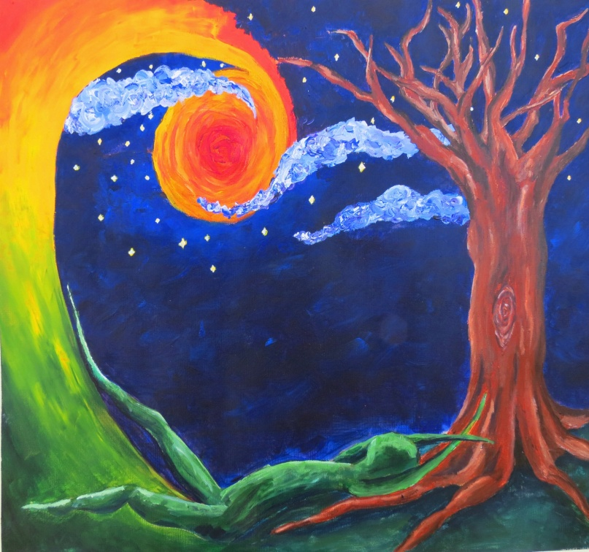
Sporting crazy eyes, a violent stare
I never let blue get to me,
We are she that he made me and I
Hold my blunt in this Technicolor world
Because “I am the Walrus, koo-koo-ka-choo”
Living, breathing, nonsense love
Gives me that funny kind of buzz
That you can’t care of anything in the world
Colors In this now swirled over the drone of silence
Evermore I take a swig, departing me to another
Land. Green filled the open air and put green leaves in my hair.
I didn’t care about he, she, or me, we were the world.
We were the future of a green world whose nose never
Curled at the ideas we hurled or the songs we sang of those ideas we claimed.
I once had a dream that I was free.

I’m Not Truly Sorry B. K. Evans
I didn’t mean to do it
I would have gotten away with it though
I’m sorry whorever I hit
Actually it felt great, but on my face, I mustn’t show

I’m only a kid, don’t do this to me
Truly, I’m a genius mastermind. Wah hahaha
Officer I said I’m sorry; jail isn’t where I want to be
Go ahead and try to put me in there you fat oaf, I will beat the law!

Please don’t call my mommy, an accident it was.
Call her if you wish, she’s dumb anyway, and doesn’t even care.
Can I just have a warning? It was only a dare that I did just because.
Because I wanted to shut the other kids up, and eat them like I do a bear.

Here you can have it back, I’m sorry I took it.
It was only a back up for my real plan.
I’m sorry I held a gun to his head, I know it was over the top by more than a bit.
No, he should have given me the money and then I would have ran.

Officer, the trouble I caused, I apologize for
But I’ll be back next week and I won’t get caught.
I promise I won’t try this again, and I will walk forever in shame on this floor.
Until my return, and next time you will hear shots.
Killers
By: Jacqueline Graham

Their minds fly
Inside a colorless world
Of synchronized fright
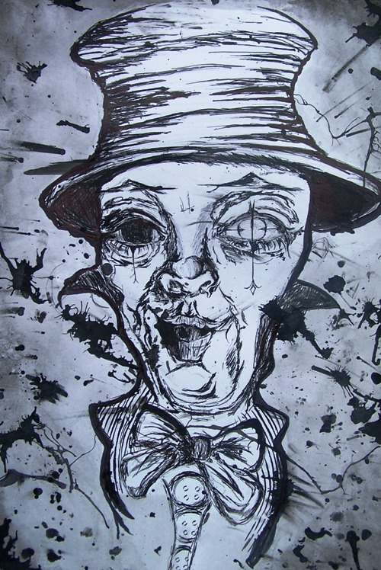
Two monsters
Connected by a firm hold

He leads
She follows
Controlling her body
While she controls his mind

Knife against her back
Gun against his head
Comforting them both
Before their next kill

Stab to the back
Execution shot
Giving birth
To a new corps

Strong hands
Choke the life
Out of a weak
Naïve soul

Red lips
Grant a welcoming kill
Opening the doors
To Satan’s corruption

Back together
In a black and white world
Splattered with only
Spots of red

Dancing until the killer
Becomes the killed

Mayfly
There once was a girl who was sunny and bright
In everything that she did
Of all beings she possessed great might
From life she never at all hid

Despite nature she was a friend to all
And tried to find good
She would rise from every fall
Different she never would

To me she always was warm
According to her I was “neat”
Far too early she suffered the norm
And now she lies there with the wheat

Peaceful always as a dove
She was picked off in her prime
She had all of the love
But none of the time

Mistress of Murder
By: Jacqueline Graham

“Not guilty”
My ass.

On the stand
Defending your word
You’re still alive,
But only just.

You have killed a flower
Raped her of innocence
In a bloody murder
Another woman gone

My job is to immortalize
Make her life live on
And the first step:
Seeing you dead.

I don’t kill with guns
Nor with poison or knives
I kill with persuasion
No man, ever able to resist

Come her dirty bum
Fall right into my trap
You will black out shortly
Followed by one last breath

It’s her turn to torture
Fulfill merciless rage
Making you feel it;
Everything you did.

Yes, I killed you.
You had it coming.

Based on the song Cell Block Tango from the musical Chicago

Nuclear Warfare
By: Lucas Lambert
Empty,
completely empty.
Cars and people,
rushing to and fro.
Children playing
riding bikes, playing catch.
Parents coming, going
busy everyday.
To work, to the game.
To the bar, to the spa.
To Tommy’s house,
To hang out with Luke.
Not anymore
All is empty.

8th street,
the busiest spot in town.
All are gone, all are dead.
The trimmed bushes,
kempt sidewalks,
white picket fences.
Dainty houses,
hues of baby blue,
soft pink,
quiet yellow.
All are gone,
empty.

8th street,
busiest spot in town
Empty?
No way!
But the enemy didn’t care.
It tore through the houses
the children, the fences,
the sidewalks, the cars.
Emptiness radiates.
Fills the air.
Sickens those,
who dare come near.
And all that remains?
Nothing
It is,

Empty

Parchment
By: Jacqueline Graham

Stain me blue and black
Open up to me
Write your sorrows
On my skin

Put your pain in me
Let your evils be released
Fill me with guilt
Make me as angry as you

Light me on fire
Burn me to a crisp
Kill your despair
As you murder me

Places
Lawson Kennan

I hold firm to the belief
That not place is ever the same
One moment to the next,
One breath from the rest.

Although I think of my world
As separate from yours,
This much I know to be true.

Water is a devious, mysterious thing,
We know it, and yet we don’t know it,
We see it, yet are still enthralled
In its shaping, shifting, twisting,
As it gently lures our gaze, our hearts.

Imagine a frosted mirror,
That reflects the rage,
And the cool serenity
Of our fleeting world.

Imagine the awe inspiring glory
Of my dear Northern Lights, the Aurora.
The everlasting night sky
Taunts me, teases me,
As it gracefully and colorfully
Dances to where I can never follow.

Imagine dull clouds, yet intriguing clouds
Looming over.
The long awaited sunshine is moments away,
Yet years long gone.
Eyes raised to the heavens,
The clouds part,
Allowing the first smiles of the God’s rays to leak through.

And imagine, just one more time,
That in one moment in time,
When things come together,
The world is beautiful.

Breathe, and the moment passes,
We observe the glory
Of the next moment, and the next, and the next,
And in each moment in time,
The world is beautiful.

Inferno
Travis Wendell

He sank into the checkered tile
The water was scolding
A fever swept over him
This was his Inferno

Towel, dry, washer
He looked in empty rooms
His stomach wobbled
Bones cracked, limbs shook

Hair that needs a host
Dangling parasitic strands
They itched and stung him
Like snakes and tentacles

T.V. equaled cluttered images
Birds knocked at his door
Searching for Mother Nature
In all her beaut and glore.

Pure Beauty
By: Bandon Burton
Her skin glistens in the sun
The look in her eyes
Shows character and beauty
And the willingness to rise
I love her so much
She holds my heart ever so kind
Oh those goose bumps
Her smile is so divine

She brings me happiness
She does no harm
Oh do I love that feeling
Of having her in my arms
So beautiful all year round
She makes everything right
And when she kisses me
It brings me all of my light

Your love take me above
To the top
Of the world
Let’s just fly
And let’s just fly
And let our wings unfurl
Darkness no more
Light oh yes
Breanna Yvonne Meredith

Sappy Love Poem About Love
Samantha Oty
I want to be your
Eve, Juliet, Jane
Catherine, and Penelope.
Your Peach
or your Zelda
Any princess would do really…
I want to kiss you in the rain,
like every terrible Nicholas Sparks book
Only minus the terminal illness.
I wish I could get lost in the woods with you
on some magical midsummer night
and never wake up from that wonderful dream.
We may never have Paris (that’s to cliché)
but we’ll always have Barnes and Noble
Because we’re cool like that.
I would love to be your June Cleaver
but let’s be serious…
I’m more Lucy than Stepford Wife.
Perhaps silent era is more for us?
We can go see the City Lights
as we enter into Modern Times.
You can be the Big to my Carrie
We don’t have the city
but we can still have the sex (wink)
I’ll even be the lamb to your lion
Yes, I did just reference Twilight,
That’s how much I like you.
But, you know what?
I don’t want any of that silliness
perfect as it may seem.
Because you are you
and I’m me
as cute as can be
and we’re better than all of them.

Smiling
By Iliyaas Reid

The beauty the grace
Her smile is so much to embrace
The days go past without seeing her face
How I wonder where her smile is in this race
I wish she was my smile to hold on
But forever she’ll be away and always gone
Her smile brightens days
Makes the rain stay away
Forever will she not be mine
For her smile is just too hard to chime

Stand Up
By: Lucas Lambert
They were called,
By people like us.
They left home,
Left their mothers,
Their fathers,
Left their wives.

They travelled to lands,
Unknown to them.
They spent each day,
In fear for their lives.
All the while,
They fought to survive
While all the fires of hell,
Rained down of them.

Their only hope,
Was written on letters,
Sent from the ones they love,
From home.

Their families were haunted,
By fear and pain.
Brothers, missing their examples.
Sisters, missing their protector.
Fathers, missing their pride and joy.
Mothers, missing their sons.

They died for us,
They deserve respect,
They deserve the liberty,
That they gave their lives for.
So now,
I pledge allegiance to this flag,
With honor,
With respect,
With a heavy heart for those who died.
And I challenge you to stand.

Stand with honor,
Give respect,
Stand Up for your country.

Sweet Nightmare
By: Jacqueline Graham

She’s never around
But she’s always there.
I know he has her
But she should be mine

Eyes that draw me in
Seductive lips say “welcome”
I won’t be capable
Of handling her “goodbye”

Slender stomach, smooth bare hips
Slither through my senses
Snake around my mind
Cutting me off from all other thoughts.

She kills me inside
I want him to die.
What does he have that I don’t?
Her.

My useless self control
Has completely blacked out.
Her warm body against me;
Feel her heart, listen to her breathe.

Her nails tear down my back
As I kiss her neck
Fulfilling my every fantasy
Of her delicate body on mine

My nightmare,
I never want to end.
His reality
That never has to.

The Enemy
I cannot tell you who I am,
But I can tell you what I want to be,
And that isn’t with you.
You knock me down,
You enter my deepest thoughts.
But I will get rid of you,
Oh you creature of depression,
I loathe you.
I loathe you with every bone,
Every part of my body.
My heart will overpower you;
My will to survive.
So surrender,
Give up alter ego of mine.
If you aren’t with me
You are against me.

No longer can we be one.

No longer can we be one.

By: B. K. Evans

The Song of the Night

In the dark, starry night, the lady moon rose,
Diamonds surround her, sparkling and bright
The mysterious beauty of the midnight sky
Bathing the world in her pale grey light.
Her song begins playing, and with it, a sigh
For her splendor fills your heart with delight
Her beauty and innocence plain on her face
Her great song of silence sounding each night
And then her sister returns, the splendid song stops
The orange supersedes the white
You wait out the day and its boring routine
And long for the song of the night.

The golden lantern of the Sun
Lights my way,
The flooding lighthouse of the moon,
Guides my way,
And the Congress of meandering stars
Is my destination.

The line I walk
Is unlike any other,
Yet I follow in the footprints
Of millions before I.

I look to my left,
And see the wealthy business man.
To my right,
I see the lonely, degraded scavenger.

We each walk our own paths,
And yet we walk together,
We’re all individually headed to the same place,
So we might as well walk together.

Lawson Kennan

Anonymous
You
are malignant.
A tumor sprouting,
suddenly visible on my skin.
At first I didn’t notice;
you were a
mark of beauty.
Then I saw it:
the ragged edge.
You grew slowly,
morphing over months
of gentle togetherness,
living peacefully side by side.
But now?
Now you are choking me.
My eyes suffer from
constant moisture;
a wretched, salty
stone,
scratching my pink cheeks
on its way down my spine.
My cheeks throb,
pulsing with the
caustic fluid that
infects my every pore.
You have taken
control of my mind.
My every thought
turns to you.
Love.
Hate.
Desperation.
Which will win?
If only I had noticed sooner,
then you wouldn’t have had the chance to
kill me.

What You See

Anonymous

You see me as beautiful
Artistically talented
And capable of anything

I wish I could be that person

You think I’m outgoing
Free spirited
Ready to face the world

I wish I could be that person

You say I’m childlike
Happy and carefree
Able to do whatever

I wish I could be that person

But you didn’t see me before
Before you and your love
Before you were mine

I would have done anything to be that person

A Dying Love
There he stood
In front of her
The man who’d sworn his love

He raised his hand
He struck her face
A slap and then a shove

Another bruise
Another lie
Another fable to be told

A shot rings out
She hits the ground
A body, still and cold

A wooden box she’s locked away
There’s nothing more to see

He sobs and mourns
A great façade
And a guilty man roams free

Nissa Bonney

Day After

Katy Kelly

A blur of tears
I’m sorrys
How are yous
I want them gone

Just leave me alone
They won’t bring him back

The food
The calls
The plans
The flowers

Just leave me alone
They won’t bring him back

So many houses
Traveling everywhere
School and people
Too many questions

Just leave me alone
They won’t bring him back

Any empty tractor
Empty field
Empty house
Empty heart

Just leave me alone
They won’t bring him back

Flamboyant Ambiance
Emma Gawthrop

I see Violet,
Purple, Lavender, Aubergine, Plum,
Amethyst floating in Wine.

I see Indigo,
Navy, Midnight, Cobalt, Ultramarine,
Pavonated gems glisten in Ink.

I see Blue,
Cyan, Azure, Cornflower, Cerulean,
Sapphires flash in Ocean waves.

I seen Green,
Jade, Pistachio, Viridian, Pine,
Emeralds scattered through Grass.

I see Yellow,
Lemon, Dandelion, Saffron, Maize,
Gold placed next to Vanilla.

I see Orange,
Pumpkin, Tangerine, Rust, Vermillion
Amber Sunrise.

I see Red,
Scarlet, Crimson, Cardinal, Cinnabar,
Rubies set in Blood.

What I don’t see is White,
Light, Colorless, Ashen, Transparent,
Diamonds covered by Snow.

All around me is Black,
Darkness, Gloom, Shade, Opaque,
Obsidian in the Shadows.

I want to see the Shades,
The Tints, the Tones, the Hues, the Colors,
Iridescent hearts gleaming with a Flamboyant Ambiance.

Jordan McCracken

If I could only speak

If ever we could be together
I would hold you to me forever
Our future together, I have it all planned
At nights we could talk long walks on the sand
The two of us would be inseparable-
I think the damage would be irreparable
Everything about you shines and burns
And of you I would never spurn
How could you choose one such as me?
There is nothing at all pleasant to see
In my darkness I plan and I plot
But it is all for naught
Of you I could never truly seek
For am I much too shy and far too meek
In Regret
Elizabeth McAuley

The sweet bitterness of life starts to hurriedly slip away.
I lie here in my painful delight.
Every moment flashes before my eyes.
I listen to the silence of the night.
As my sorry existence plays nosily in front of me,
I pause.
I sift through my shadowy past and see a light.
I realize my worth in that second.
There is a brilliant glint of happiness.
I see things I overlooked before committing to this.

I panic.

I want to live.
My life is full of so many wondrous things.
I am simply throwing it all away.
I thought I trusted myself.
But I thought too quickly.
Now I am drifting into an unknown afterworld.
Attempting to grasp the last few seconds of my life is overwhelming and pointless.

My body will not react.

I dimly see myself falling into oblivion.

I am dead.
I lived my last moment in regret.

Love
Joseph Jacobs

I cut the hearts of those who stand in our way
Leaving them writhing in pain
Bleeding in agony
As they call my name
I steal their souls
From out their broken hearts
Leading them with my seduction
My lustful coercion
They are all mine in the end
I hold all their hearts
In my leading hand
Letting the blood
Trail to a river
And a puddle
At my feet

Me
A lonely person
On a broken road
Feels like life
Is down the hole
No friends has he
All lonely and cold
He wishes he can fit in
But his wish is blown away
One place he can never say
Putting a mask on everyday
This person I tell you
Is a person I know well
This person is myself

-Mark T. Livermore

Joan Brannon
“He who walks in another’s tracks leaves no footprints.”

My Footprints

You want me to follow in your footsteps,
And I have obediently.
Driven by love I have blindly followed you,
My only dad.

No matter what the case, I have been behind you
Watching every move you make.
I have practiced each move and each step you have taken
To the point where I make no mistakes.

But when I look back I only see one set of footprints.
My footprints have become yours.
And when I think of my life
I can only see yours.

This has troubled me
Because when I have a son
I want him to love my set of footprints
Just so one day he can break away from them
And become a man of his own, just like I have, today.

Jesse Phillips

Ode to Skinny Jeans
By: Jacqueline Graham

Skinny jeans, oh skinny jeans
Where for art thou skinny jeans
In the dryer or in my drawer
On my legs or on the floor
Skinny jeans, oh skinny jeans
You are for skinny people
People like me
Who wear sizes
One, two, or three
Skinny jeans, oh skinny jeans
But those who wear you
Whose legs are a tad fat
Don’t quite realize
You can’t elude that
Skinny jeans, oh skinny jeans

Passion Awakened, Heart Asleep
By: Emma R. Gawthrop

After a million years I might make a mistake,
Which road should I take?
Whose love was fake?
Whose heart is breaking,
Yours or Mine?

After a million miles, with twenty more to go,
Which path should I follow?
Whose feelings are shallow?
Whose hear is hollow,
Yours or Mine?

After a million tears have been shed,
Which way was I lead?
Whose emotion was spread?
Whose heart is dead,
Yours or Mine?

Player
By Taylor Vaughn
(using a comparison, describe how something burns or cooks)
How can so much love
Be destroyed in such a
Small piece of paper ,

How can a little tree
Latter word ruin my
World and how come you
Seem to be full with nothing
Other than this word ,

You say all this wonderful
Things though you always
Mass it all up by the end,
“I love you but I care a
Lot for her” “you’re my
One and only but I’m still
With her.” “Love but not
All the way Tom.”

There is this anger
With in me, you
Have to pay. I go to
Find the close thing
To hell in have

I’m going to give back
The devil his word of hate,
But what a stupid word
But I hate you so much
But I you forever burn
With you master.

I though the heart
Stopping latter in the
Red ball of my own
Hell and watch all the
Evil words go golden
Drown and turns to ash
Like it belongs

Thin all that was left
Was the name, the
Perishes name that
I would crave to see
on every page thin it
to turn as black as his
heart.

Goodby my lover
I’m tired of playing
You silly games
Oh that’s right you
Wasn’t really my lover
You was just my player!

Puzzle Pieces
Travis Wendell
Two puzzle pieces
Each of different shape
Distance and departure
Different life and decay
An uneven foundation
Built on ill-told jokes,
Cliché falsehoods,
And empty promises
Balance tells the truth
The pieces don't fit
Pressed, turned, skewed
Their hearts don't shift
The pieces are not useless,
But merely misused
This puzzle isn't the past
It's the future, imbued.

Rolled Tobacco
Courtney Grubb

The inhalation of smoke,
The burning ember,
The flaking ashes…
Reaching out, reaching up,
an itch for that which we cannot have.
Like a cigarette burning in the hand of a child, we all find fascination
within the depths of our
backwards minds, interpretation
of dreams; life is a game of roulette.
Pushing daisies, twirling tulips,
frisking fancy futile felines…
our silly little puppet show, our every
desperate effort goes out to the crude audience, curdling
our innocence and fattening
our skins. We are all garbage in an ashtray, leftovers;
once a part of something, important
to someone, somewhere. A dire
need, an honest desire…
A mysterious taboo.
Frowned upon by those high society scholars,
they’re too good for that.
Perched with their necks extended to the
clouds of heaven, leading (leaving) the rest
of us from our path of destruction to theirs of corruption.
M A R L B O R O
That cigarette bridges the gaps of
society in the hands of a child,
breaks the chains of separation,
but with such varying interpretations one cannot be sure
of where she lies in this word game.
Makes known their desire to be us and ours to be them while what we have will never be
good enough but what they have—or don’t—surely will, for they are simply ungrateful.
The smokestick plucks away the
child’s innocence with every puff
while he watches his father do the same.
Innocence…
Just as the cigarette burns away
inch-by-inch;
in this bored game we’re playing, our timer is running out of sand.

Someday

Katy Kelly

You see that girl?
Someday you’ll hug her
And bask in the feeling of her
close to you.

You see that girl?
Someday you’ll hold her hand
and yearn for the way it fits
so perfectly in yours.

You see that girl?
Someday you’ll touch her
embrace her warm body
and trace her skin.

You see that girl?
Someday you’ll kiss her
until the world stands still
and she is all that matters.

You see that girl?
Someday you’ll hurt her
and you won’t mean to
but it tears you up inside.

You see that girl?
Someday you’ll love her.

You see that girl?
Someday she’ll love you too.

Savannah
Courtney Grubb

Silently padding over the horizon,
she watches everything around her,
observing every little movement…
hearing every gust of wind.

Her vibrant orange fur
stands out amongst the monotone grasses,
but she knows well
how to blend.

A gentle giant, her
wide green eyes shift
left

right

left

right

left…
alone for an instant,
happily distanced from the pack.

Her hungry nose twitches
as the pack’s carnivorous
fumes reach her hiding place;
she slowly retreats back to them,
vigilant to the frenzy.

Her rippling back
saunters closer, one
ear still pitched to the
wind at her tail.

Home again—
home, or hell?
She wonders wordlessly,
humble eyes glazed over
as she slumps to the ground,
longing for independence.

Stop the Clock
By: Jacqueline Graham

Stop the clock
When boy meets girl
So puppies can play
In childish love

Stop the clock
At the alter
Before you commit
Changing two lives forever

Stop the clock
On the ninth month
Gaining responsibility
Adding one more

Stop the clock
When I am grand
Take me back
To relive it again

Terminal Diagnosis
Courtney Grubb

Voyage to the sunset—
mysterious
silent
floating gently across water,
my little sailboat and I.

My mind is fading
quickly as we drift
tenderly over
evanescent waves,
lapping up my little sailboat
like a dog its water

My sailboat and I—
my body, my mind…
float swiftly away from
shore, fragments
left behind, perhaps
dragged along the undertow

a memory resurfaced,
glistening,
will they remember me?
me and my little sailboat?
when we can’t remember them?

The Friends by the Moon
By Lauren Mathews

The smell of old warmth that I used to know,
With a deep sense of love that filled a room.
A vacant old chair by the window of snow,
Near a heart that cried that October at noon.

You sit in my jewelry box, labeled my name,
The one from China on the trip round-world.
Untouched, it doesn’t feel the same,
A secret hiding place known only to a girl.

It means a lot, those words you say,
Even if I forget them, I feel your faith,
And though mine has a new direction or way,
I keep you close to my soul; your presence is my safe.

Along the Shenandoah Parkway, the house and the coast,
Those specs of you physically kiss our nose.
The voice, the music, the melody missed most,
But isn’t this life, just how it goes?

An unsealed envelope in paper and ink you lie,
A close hit to home, the smell calms my heart.
Once. I read and I accept these tears in my eyes
As I blink silently, softly, while falling apart.

But you give me strength for the music in my blood,
To sing a heart-felt harmony and carry my tune,
To a melancholy melody that grows a new bud
In a new place I call home, with friends by the moon.

I loved and I lost, the hole from a soul,
Who began original “once upon a time’s” at my request,
I laughed, I grew old, and I watched the cancer take a toll,
On the most beautiful person that peace let rest.

But now she sings proudly, my bright warrior in a star,
Never would say peace took her too soon,
She watches and graces us all from afar,
Me, and she, with our friends by the moon.

The Storm
Katy Kelly

Mommy and Daddy are yelling
Their voices slamming into each other
Like water hitting the beach during a hurricane
Their voices surge up
Wind roaring past my head
I need to take shelter
I need to hide
From the rain of their anger
The waves crashing over me

Slowly their voices recede
But the room is too quiet
Too still
Now more than ever I need to hide
Because once they eye of the hurricane passes
The storm will come back full force

Trees
We planted it the first day I arrived. It has grown with me ever since then. Stretching up to the sky, challenging the limits of the world.
I walk around this tree everyday. Hug it; feed it; cherish it. Others do not love this tree. They call it a corruption to their yards because of falling leaves.
No matter what they say, I will continue to help this tree grow. By the end of its days it will have a strong base. It will branch out its limbs, shading the ground underneath.
This tree is and always will be my better half.

By: B. K. Evans
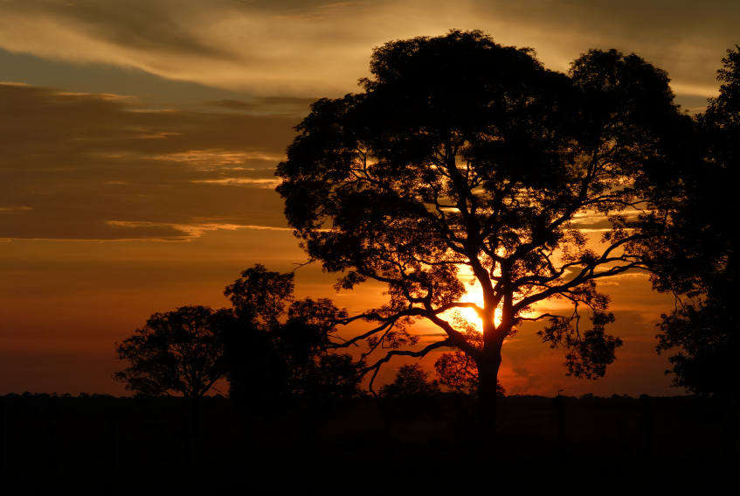

Shaylee Hodges
I’ve noticed something

Unusual.

Are your eyes
Red?
Is your cheek
Wet?

How unusual.

Is your hair
Messy?
Is the bed not
Made?

That’s unusual.

Is your gun
Loaded?
Is your gun
Cocked?

Why are you saying
Sorry?

Unusual…

After the Curtain Closes
Courtney Grubb

Their movements cast
an olive color over the crowd;
a melancholy, luminescent ambiance
of sorrow.

Constricting conformity,
lonesome, mind-wandering
importancies clouding her
projected thoughts.

His concentrated fingers
supporting her lax spine,
his strength clearly visible
but impossible in all rational thought.

The clumsy, rotten boards
collide with her feet,
surprised when she keeps on moving,
skittering round in succinct circles.

The man stands tall and lanky,
a slim, sturdy statue
in the dark of a bright city.
His brilliant eyes shine outward, a spotlight away from him.

Their dance continues quietly
even as the audience is leaving;
clandestine intimation of an obligatory alliance.

THE DAY AFTER POEM
The day after tomorrow is the day before today,
Only the day after tomorrow I won’t be feeling this way
When my mind has escaped my souls embrace,
I will embark on a journey at my own pace

Because the day after tomorrow isn’t a day at all
That day called tomorrow I won’t be seeing you all,
I’ll be an empty body meandering the hall
And an unanswered phone to the number you call

You told me I should so I would even though I know
That maybe it wasn’t the right time to go,
But you said “He” wouldn’t care for he hated our kind,
The ones who were different who seeked different’s eyes

But now I’m gone and maybe you’ll feel better
Knowing you killed the girl with the guy’s sweater
Or the guy with his secret held from you
Move past hatred and learn to accept true…

True colors for the rainbow they bring
Maybe one day wedding bells can ring
To a person you stepped up to save?
In the land of the free that’s lacking the brave.
Free
The pain that drives you mad,
is the same pain that holds you together.
You feel like breaking, but deep down,
you know you can’t give up.
That aching in your heart is the
proof that it still beats,
And while the rhythm continues
there’s always the chance that another
will mend it again.
Each step feels unbearable,
But you keep taking another,
One foot, then two.
The shadows peeling away your sanity,
will eventually die as her lips
brush against yours.
That warmth will return,
Murdering the cold that you let
yourself be devoured by.
And when she breathes life back
into your soul,
You can be free again.
Bri Burton 3-9-12

Crying
Ilyiaas Reid

Loving you is like crying
Missing you is like dying
I wish I never lost your heart
Cause now we seem forever apart
I stay awake into the night
It seems like it’s not right
That your love is not inside my heart
Today, I wish we had a fresh start
Girl, our love was once so pure
Now it ‘s all so insecure
Trusting me seems so hard
But never having you has left me scarred
Girl, I cry a million times
Just because I lost your chimes
I love you with all my heart
But crying is just tearing me apart.

Make Me a Sandwich
By: Jacqueline Graham

Independent, I am
In no need of a man
I can work just as hard as he

Dear, you should be home
Cooking him food on the stove
That is what you were made to be

I wasn’t made to be that
Now watch me fight back
And be whatever I want

Sweetie, you need to be supported
A man can surely afford it
He’ll make lots of money
And call you his honey
Tall this thinking and abort it

I’m sick of remarks that are sexist
A sandwich should be made when I request it
I am a women, damn it
I have more to offer than man.

My Room.
By: Taylor Vaughn
Chained doors and My heart can beat
Barb weir fences as loud as the
Not to lock in but music that flows
Out all the pain the tough these
World loves to shed tainted walls

Here I can love my soul can
Who I want Rome free as
Say what I please my pen dose
And mot care on paper with
What anyone thinks out any conviction.

I can cry with
Out a reason
Or laugh with
Out a joke

The fire within me
Can finely be shown
And my thoughts
Will finely be herd
Though no one’s there

Pulling Petals
By: Emma R. Gawthrop

Once upon a time
I believed in fairytales
In happily-ever-after’s
Waiting for my Prince to come

Pulling petals from a daisy
Counting them out beforehand
So I would always land
On “He Loves Me”

But then I found
A path marked “Reality”
Curious, I tiptoed down
And was surrounded by brutality

No matter how many petals
I pulled, I was missing one
Kept checking my vitals
But my heartbeat hadn’t gone

Once upon a time
I believed in fairytales
My dreams chasing after
Someone who would never come

Pulling roses out of flowerpots
Petals falling into dust
But no matter what
I kept landing on “He Loves Me Not”

Rules For A Sonnet
Allysand McIntyre

A sonnet requires four -plus - ten lines.
It needs a parameter; perfect talent.
It needs a totaling of seven rhymes.
And be written with emotion; nonchalant.
Double-A, Double-B, Double-C, D
Rhythm and rhyming go hand in my hand.
Rhyming is a task that some find easy.
Come on sir; take my challenge if you can.
Be prepared to write a sonnet from the heart.
Select your format, like Shakespearean,
It is much simpler, better for the start;
The harder of the two’s, Italian.
Complete my task, write yourself a poem.
Keep these rules at hand until you know ‘em.

Heal and inflict pain
Provide pleasure and create hurt
Form and destroy
Pray and cast away
Steal and give
Hold and release
Gentle and forceful
To love and show hate
Beg and reject
Bring close and make distance
These are my tools
Touch them and understand my life
Feel them and experience my spirit

-Elizabeth McAuley

Jordan McCracken

It never leaves my mind

Of all the things I have experienced
I would wish to be with her
Of all the things that could be perpetual
I would wish for that time
Of all the things I have ever lost
I would wish to have that most
And of all the things I’ve ever dreamed of
I would wish to dream of it more

Travis Wendell

Blinded Drivers

She fell in heavy drops
Soaking every surface
Sliding down windows
She blinded drivers

White-knuckle steering
Tires slipping on blades
A sold out show on ice
Where no one’s sober

No chance at the start
On playgrounds she was
Making artwork run
And fire ants sprint

Home was puddles
Her splashes a song
Forever she trapped
Explorers at sea.

Sewn to Me
Elizabeth McAuley

The lonely abyss of my burdened mind grows darker every second.
I cannot look in the mirror without seeing this stricken outsider.
I wish to remove this mask of deceit but it is sewn to me.
I falsely give you the affection you so vainly think you have earned.
You have earned nothing.
You are nothing.
You abuse and criticize me.
All I can do is insincerely tell you, I love you.
The truth is I genuinely loathe your very existence.
Let me do you a favor my love.
Let me strip the life from you.
Let me relieve myself of your disturbing presence.
Let me scoff at your last miserable moment.

Species of Happiness
Courtney Grubb

Humble trees smile at me,
whispering their welcome.
Violet sun waves goodbye
as she sinks behind the horizon.
Elder leaves groan and grumble as
I step over them,
grumpy with old age.
I take a seat against my
favorite companion—a tall, handsome fellow with brilliant auburn hair.
His warmth calming as he
warps comforting arms around me
to a relaxing embrace.
The wind sighs her relief—
or perhaps jealousy—
that I made it out again.
Younger stalks skitter about,
frolicking in the final
daylight hour before bed.

Older
By: Jacqueline Graham

Small, feeble
Silent, nearly motionless.
Snowy white hair
Curved around her face
Surrounding icy blue eyes
Glazed with despair
She wants to speak…

Fingers boney and curved
Moving them slightly
Knitting the air without needles or yarn.

She doesn’t recognize me
Though my picture sits beside her
She looks over to the wall
Eyes fixed on a black and white photograph

A man smoking a cigar
Holding a rifle over his shoulder
She reaches toward the photo
Touches the rifle
Then his face

“Gen” on the barrel
She misses her soldier.

The Broken Rises up and the Redeemed Follow

By: Brandon Burton
Fight for what you believe is right
Stop at no cause
Never care for what people think of you
This whole world has flaws
We as humans have a voice
So let it be known
We must reach up for our goals
And stop being alone

In a nation where we discriminate
Let’s stop and coexist
And stop judging each other
And making our youth slit their wrist
Make a difference
And put down the gun
And let’s work as a team
And stand together as one

As this pencil hits paper
I ask of you to stand
And shout so loud
Everyone can hear you across the land
This is not your average “let’s try and change the world” poem
It’s a plan to unfurl
And it’s a guarantee promise
That we WILL change the world

The Jump Shaylee Hodges

I looked over the ledge.
A noise. A sound. Anything?
The dirty wet asphalt
Glistened, even up there.

The lights that flickered looked
Like tiny stars
Dreaming in the milky way.
The sidewalk below me
Was nothing.

No more to me than the cold earth.

I held my breath
And counted.
One. Two. Three.
And I jumped.

Tight
By: Jacqueline Graham

Go ahead
Scratch me again
Make me bleed
Please your taste

Bite my lip
Taste my tongue
Take my blood
Put it in you

Hold me tight
Tighter than tight
Steal my air
Keep it for you

Com closer
Heat me with your flame
Snatch it away again
Satisfy yourself

Don’t hit me again
I’m sorry, you can
My tears don’t matter
Just fuel to your rage

I love you,
I hate you!
Please don’t go…

Oh trust me, I seen this all coming.
By: Brandon Burton

Living life to the fullest
But then the bass drop hits
Your life spines out of control
Does everything seem legit?
Everything is dark
Nothing is bright
Why put ourselves though such pain?
Is there no end in sight?

Oh, just another fake life
It comes back around
Fake friends and fake smile
Everybody on the ground
Oh regret, sweet smelling regret
You’re here to haunt me again
But today I erase it all
Till the very bitter end!

“We Bad Boys” by Sara Cerv
We bad boys. We
Steal toys. We
Skip school. We
Too cool. We
Do drugs. We
Are thugs. We
Say bye. We
Then die.

Pipe Dream
Courtney Grubb

What if
dreams are not
fantasy, but
are reality?

What if our living
is really just dying;
floating up to the heavens
or down to the depths of hell?

What if
sleep was not so
sinister,
but yet embraced as fluid truth?

Instead of
trying to remember
our dreams,
perhaps we’d be striving
to forget the things
awake.

Sun
By: Joseph Jacobs

The Sun
Comforter of the Earth
Its rays of warmth
They caress the Earth’s frame
Giving it Life
Hope
Light
Together suspended
Cuddled in this universal bed
Holding it in its warm embrace
Even on the coldest days
It finds a way
Maybe not with warmth
But light
To wake the Earth
Waking in harmonious light
To face the cold season ahead
I am a Sun
And I have found my Earth

